Practice Test: Web Design

# Part 1: Multiple Choice (10 points)

1. _____ The type of code responsible for controlling the style of a webpage is
   1. HTML
   2. CSS
   3. JavaScript
   4. Java
2. _____ The <a> tag is to href as the <img> tag is to
   1. longdesc
   2. alt
   3. title
   4. src
3. _____ Most elements have ____ tags.
   1. one
   2. two (opening and closing)
   3. three (opening, closing, and a text node)
   4. none (elements don’t need tags)
4. _____ Which of the following is a proper HTML comment?
   1. <! comment>
   2. <!-- comment />
   3. <!-- comment -->
   4. /* comment */
5. _____ The element that displays in the tab of a web browser is the
   1. title
   2. h1
   3. h6
   4. none of the above
6. _____ The tag for the paragraph element is the _______ element.
   1. par
   2. paragraph
   3. p
   4. pg
7. _____ HTML code that does not appear on the webpage itself is found in
   1. CSS
   2. the head element
   3. the body element
   4. any of the above
8. _____ Which of the following is an empty (void) element?
   1. <p>
   2. <html>
   3. <hr>
   4. <h1>
9. _____ To aid blind people trying to access your website, you should use the ______ attribute.
   1. alt
   2. title
   3. href
   4. src
10. _____ The copyright symbol in HTML needs to be made using an HTML entity with the code
    1. copy;
    2. &copy;
    3. cp;
    4. &cp;

# Part 2: Short Answer (10 points)

1. What is the difference between <br> and <hr>?
2. Where does the title element go in the code?
3. What is the purpose of the meta tag?
4. Why is indenting important?
5. What is the difference between html elements and tags?

# Part 3: Code Writing by Hand (10 points)

Write the code for the page displayed below.

IMPORTANT: Only write the code that would go in the body section of the webpage. Assume that there is a file named bamboo.jpg in the directory directly above the one your HTML is in (i.e., the parent directory).

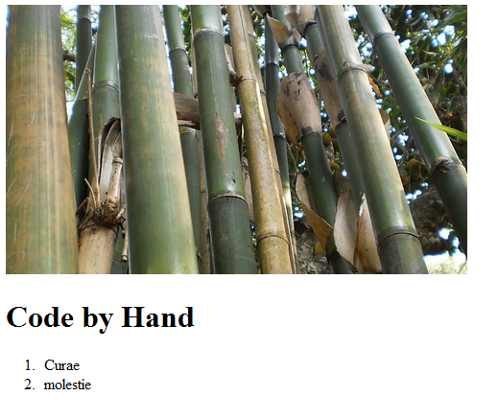

# Part 4: Code Writing on the Computer (10 points)

Write the code for the page displayed above.

IMPORTANT: Must turn in parts 1-3 before starting this. All resources are allowed.